Part II

Problem analysis

Generally speaking, because the cost of oil storage is relatively high relative to the cost of production, the oil consumption curve and oil production curve are consistent in most cases. But from a dialectical point of view, consumption also has a counterproductive effect on production, so Part II will focus on the future world demand for oil.

One of the greatest global challenges is to integrate environmental sustainability with economic growth and welfare by decoupling environmental degradation from economic growth and doing more with less. Resource decoupling and impact decoupling are needed to promote sustainable consumption and production patterns and to make the transition towards a greener and more socially inclusive global economy.

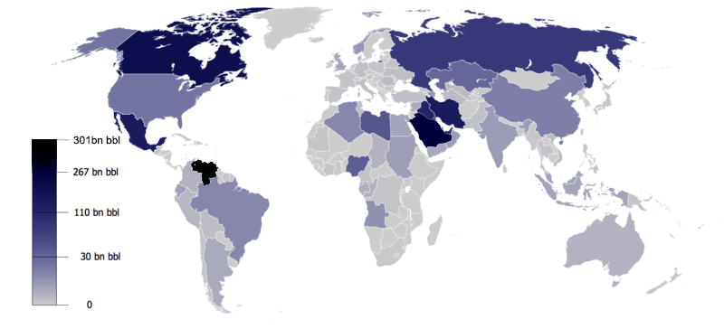

图：各国原油储量

一个事实是：世界上的石油分布是不均衡的。而最新的研究表面，像二甲醚，甲醇等新型合成染料也能很好的替代石油。我们从石油的替代品的角度出发，考虑石油的消费量的变化趋势。

One fact is: the distribution of oil in the world is uneven. The latest research shows that new synthetic dyes such as dimethyl ether and methanol can also be a good substitute for petroleum. From the perspective of oil substitutes, we consider the changing trend of oil consumption.

Model construction

We should first determine the total amount of energy required by humans. We have obtained data on world population, per capita energy consumption and world total energy consumption. First, fit the curve of world population and per capita energy consumption:

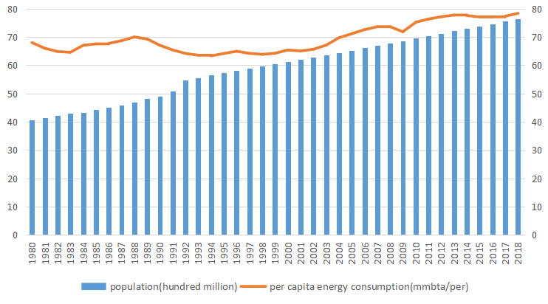

图：世界人口和人均能耗的预测

It can be found that the two values are both linear. Using the fitting results, we have predicted the world total energy consumption. It can be found that for the past data, the predicted results are in good agreement with the actual situation.

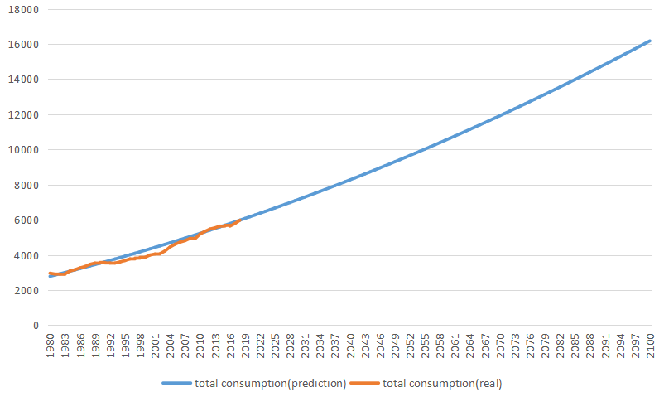

图：世界总能耗的数据和我们的预测

In the end, our predictions for energy supply from various resources are as follows:

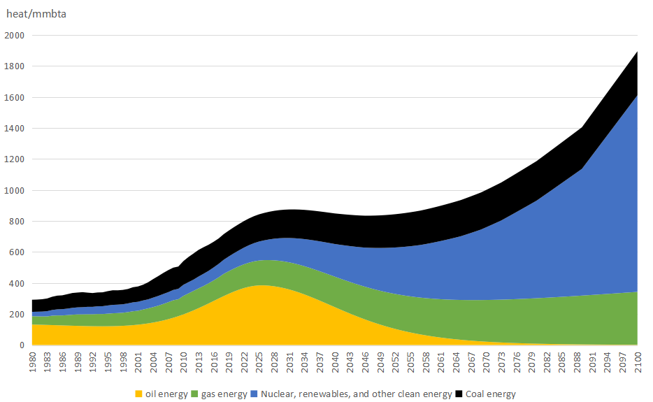

图：各种能源消耗量的预测

可以发现，由于技术限制，核能、生物质能在近10年内还无法大规模推广，因此必须由石油提供能量，来满足人类社会日益增长的需求，石油消耗也随之迎来峰值；但是随着合成燃料技术的进步，地球上储量更多的煤矿被投入使用，缓解了石油耗尽的危机。此外，更多的清洁能源也将被研发出来（比如可燃冰），石油也就随着石油的生产成本的提升而逐步下降，最终推出市场。

It can be found that due to technical limitations, nuclear energy and biomass energy cannot be promoted on a large scale in the past 10 years. Therefore, oil must be used to provide energy to meet the increasing needs of human society, and oil consumption will also reach its peak; With the advancement of synthetic fuel technology, more coal mines on the earth have been put into use, alleviating the crisis of oil depletion. In addition, more clean energy will also be developed (such as combustible ice), and oil will gradually decline with the increase in oil production costs, and finally be launched on the market.